

**DATE : May 29, 2020**

**TO : ALL CONCERNED**

**SUBJECT : RE-ACCREDITATION OF THE CIVIL ENGINEERING PROGRAM**

Greetings!

We are pleased to inform you that the **CIVIL ENGINEERING** program of the College of Engineering is granted re-accreditation for three years by PAASCU.

We take this opportunity to extend our sincere thanks and appreciation to everyone who gave their unselfish support and cooperation for success of this endeavor.

God bless and keep safe!

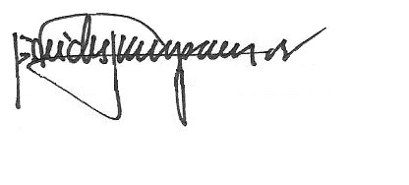

REV. FR. CRISTOPHER C. MASPARA, OAR

President

/bvs